Project Name: Find a Pump
Team Name: Gas Guzzlers
Team Members:
Eric Parral, Nathan Carlson, Kyler Cressall, and Thomas Ross
Team Lead Eric Parral
Project Description
Overview and Justification
Find a Pump is a web-based application that strives to help users find the gas station with the cheapest gas near them in Utah County. To help users find a pump that fits their needs, they will be able to filter the results by type of gas (diesel or regular), quality, or even find an EV charger. Users will be able to add in any discounts they receive at specific gas stations to be factored in automatically for them. They will also be able to modify the search area, which will allow them to choose how far they are willing to go for the cheapest gas.
Find a Pump aims to alleviate the pain points of constantly fluctuating gas prices and the current inflation problem by providing users with the latest price information available. This will take the stress out of spending too much money on gas and remove the uncertainty of what the price will be. Utah County is full of college-aged adults who typically have tight budgets and do not have the ability to spend frivolously. Providing them with the cheapest gas options will allow them to enjoy their time and use their money where it matters more fully.
Tech Stack and Measuring Success
The application will integrate Google Maps APIs to provide accurate geolocation and redirect Google Maps to get turn-by-turn directions. A responsive frontend with React will display station distance and current fuel or charging prices. The backend, powered by Node.js with Express, will manage API requests, data aggregation, and communication with external APIs. A local SQLite database will store station metadata, user preferences, and cached results to improve performance. Then for the data processing the application will use JavaScript for the caching and aggregation. Together, this tech stack creates a scalable, intuitive, and reliable application that enhances everyday travel planning. 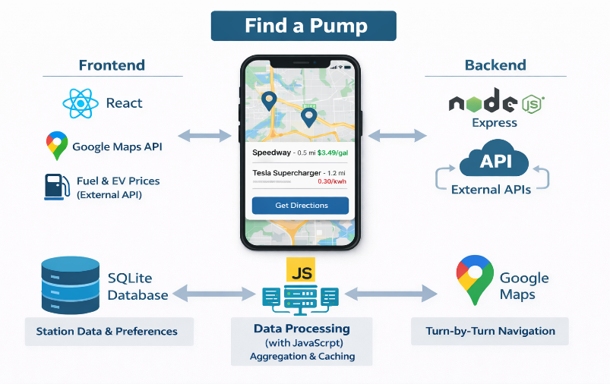

The application is complete once it has met its core functionality goals, reliably retrieving and displaying nearby stations with accurate distance and pricing information. Verifying that the Google Maps redirection works consistently, ensuring seamless navigation for users. From a UI/UX perspective, the interface is clean, responsive, and intuitive, while map interactions such as zooming, panning, and marker selection feel natural. If launched, the shipped version will demonstrate powerful performance, with average API response times under five hundred milliseconds and map and station data loading within two seconds. The user engagement metrics should indicate healthy adoption, reflected in steady daily active users and frequent station lookups per session. Lastly, in terms of reliability, the application maintains 99% uptime over a 7-day period, with API error rates kept below 5%.
API Research
To power our app, it will need live, accurate price data for the different fuel types at gas stations across Utah County. The best way to do this is to use an existing API, which hosts this live data already. One example of an API the application could use is like the one hosted at “www.oilpriceapi.com,” which can give the real-time prices of fuel at each station filtered by latitude and longitude coordinates with a radius around it. This data will include the prices of the fuel at each station for us to use to display and sort.
To get accurate live data of these prices, when the user opens the app, it will get data from the API. That can store it in the app database to display prices on the map. If a user launches the app again offline or if the API is down, it will use the existing prices in the database to continue to display information. Storing the data from the API in our own database will limit the number of times the API is called, as well as give us more flexibility for querying and displaying the data.
Google Maps API is what will power the geospatial mapping portion of the application. It allows us to use JavaScript to create a live map pulling from Google Maps and then be able to add many pins/markers on the map as needed. This streamlines the process, so all that will need to be done to implement it is to create an API in our backend to query each of the station’s coordinates and prices, then iterate through them, placing them on the map.
Potential Features and Stakeholders
This application is designed to help consumers in Utah County quickly locate nearby gas stations and compare fuel prices in their area. Using the user’s current location, the system will display gas stations on an interactive map or in a list-based view, allowing users to easily identify both the closest and the cheapest options available. Key features include location-based search, fuel price displays for multiple fuel types, distance indicators showing how far each station is from the user, and sorting or filtering options that allow users to prioritize proximity or cost. These features are intended to save users time, reduce fuel expenses, and simplify the decision-making process when choosing where to refuel.
The primary stakeholders of this system are drivers in Utah County who directly benefit from easy access to nearby gas station locations and fuel price comparisons. Secondary stakeholders include gas station owners, who may experience increased visibility and customer traffic when their stations appear as competitive options within the application, as well as third-party API and data providers that supply the location and pricing information used by the system. Indirect stakeholders include members of the local community, who may benefit from reduced unnecessary driving, and the development team. Those who are responsible for ensuring the system remains dependable, accurate, and user-friendly.
Meeting Logs:

Contribution Form
Team Name  Gas Guzzlers | Sprint # | Date | Team Score
Name |  | Contribution (%) | Signature | Individual
Eric Parral |  | 100% | Eric Parral | 100
Nathan Carlson |  | 100% |  | 100
Kyler Cressall |  | 100% |  | 100
Thomas Ross |  | 100% |  | 100

Backlogs and Sprints
Sprint # | Assigned Date | Backlogs | Description | Assigned | Finish Date
Sprint 1 | 2/15/26 | 1. API | Get an API key to access gas prices.
 |  | 2. Data | Get more data to test the API.
 |  | 3. Pin | Get it to accurately place a pin on the map.
 |  | 4. Env/key | Get access to the map key and have it secured by everyone.

Software Requirements Specifications
Functional Requirements
Core Display
- The system can detect the user’s current geographic location either automatically or via manual input.
- It will display gas stations within a selected radius on an interactive map.
- Display fuel stations using map markers with station information.
- Each station will contain all fuel types and prices for its location, including regular, mid-grade, premium, and diesel.
- Display EV charging station availability if selected.
- Users can select stations to view the full details of a station, including its address, a link to open directions in Google Maps, and the current prices of each of the fuel types.
Search and Filtering
- Users can view stations nearby as a list as an alternative to map view.
- Users can filter stations by distance or price.
- Users can set a preferred fuel type to make the map and list display that price first.
- Allow users to input personal discount programs tied to specific stations.
- Apply discounts automatically to pricing results.
- Allow users to modify or remove previously entered discounts.
Data Handling
- Cache the latest retrieved fuel price data in the local database.
- Display cached data if the fuel-pricing API is unavailable or the user is offline.
- Automatically refresh cached data when an active internet connection is available.
- Show when pricing data updates using timestamps.
Error handling
- Notify users if the location cannot be determined.
- Notify users if no stations match their filters.
- Display an error message if external APIs fail.
- Show previous data when using cached results.
Non-Functional Requirements
Performance Requirements
- The system shall provide API responses within five hundred milliseconds on average.
- The system shall load map and station data within 2 seconds.
- Search and filter results shall update within 1 second.
- The system should support at least five hundred concurrent users.
- Cached data retrieval shall not exceed two hundred milliseconds.
Reliability and Availability Requirements
- The system shall maintain 99% uptime over a 7-day period.
- The system shall automatically recover from crashes.
- The system shall provide fallback functionality using cached data.
- The system shall synchronize data after downtime.
- The system shall detect and handle unavailable external APIs without crashing.
Usability and User Experience Requirements
- The system should provide an intuitive interface.
- Users shall be able to access core features within three clicks.
- The interface shall be responsive for desktop and mobile devices.
- The system should provide clear visual indicators for stations.
- Loading states shall be displayed when data is being fetched.
- Error messages should be user-friendly and actionable.
Scalability Requirements
- The system shall support future geographic expansion.
- The backend shall allow horizontal scaling.
- The database shall support large datasets efficiently.
- Sensitive configuration values shall not be hardcoded in the source code.
Security Requirements
- API keys shall be secure and stored.
- User input shall be error checked.
- The system shall implement rate limiting.
Maintainability Requirements
- The codebase shall follow modular design principles.
- The system should include documentation.
- The system shall support automated testing.
- Version control shall be implemented.
- The system shall follow consistent naming and coding standards.
Portability and Compatibility Requirements
- The system will operate on major web browsers.
- The system shall support multiple operating systems.
- The interface should be adapted to different screen sizes.
- The system shall function without requiring browser-specific plugins.
Data Accuracy and Integrity Requirements
- The system shall validate API data.
- All stored data shall include timestamps.
- Duplicate records are to be prevented.
- Cached data shall be updated regularly.
- The system shall clearly indicate when displayed data may be outdated.
Accessibility Requirements
- The system shall comply with WCAG 2.1 standards.
- Keyboard navigation shall be supported.
- Screen readers shall be compatible.
- High-contrast display modes shall be available.
- Interactive elements shall include descriptive labels or ARIA attributes.
Logging and Monitoring Requirements
- System errors shall be logged.
- API usage shall be monitored.
- Performance metrics shall be recorded.
- Administrators shall receive failure alerts.
- Logs shall include timestamps and severity levels.
Backup and Recovery Requirements
- The database shall be backed up daily.
- Backups shall be verified regularly.
- The system shall support data restoration.
- Backup data shall be stored securely.
Legal and Compliance Requirements
- The system shall comply with Google Maps API policies.
- The system shall comply with fuel data API licenses.
- User privacy shall be protected.
- A privacy policy shall be provided.
- The system shall not store personally identifiable information without user consent.
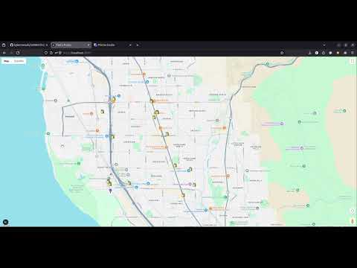
Demo Video/Prototype
To access the code, please go to this GitHub: https://github.com/kylercressall/cs4400-findapump

Design
Architecture Diagram
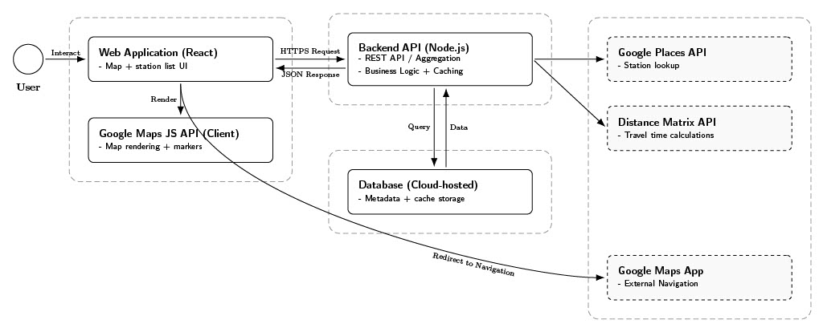

Table 1: https://github.com/kylercressall/cs4400-findapump/blob/main/documentation/UML/Architecture_diagram.pdf
This diagram illustrates the three-tier architecture of the Find A Pump system. The React frontend communicates with the Node.js Express backend via RESTful APIs. The backend integrates with external services including the Fuel Pricing API and Google Maps API. A SQLite database stores caught pricing data and user preferences. This design ensures separation of concerns and supports scalability.
Entity Relationship Diagram
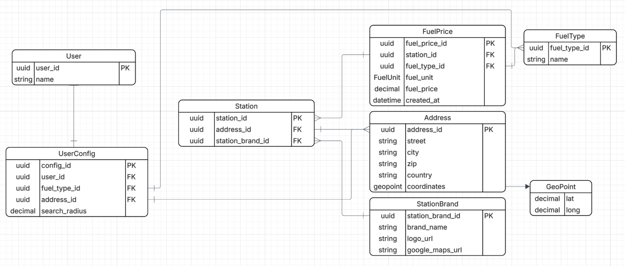
Table 2: https://github.com/kylercressall/cs4400-findapump/blob/main/documentation/UML/entity-relationship-diagram.png
The ER diagram defines relationships between Stations, Fuel Types, Prices, and User Preferences. Primary keys and foreign key constraints ensure data integrity. Timestamp fields are included to support caching validation.
Use Case Diagram
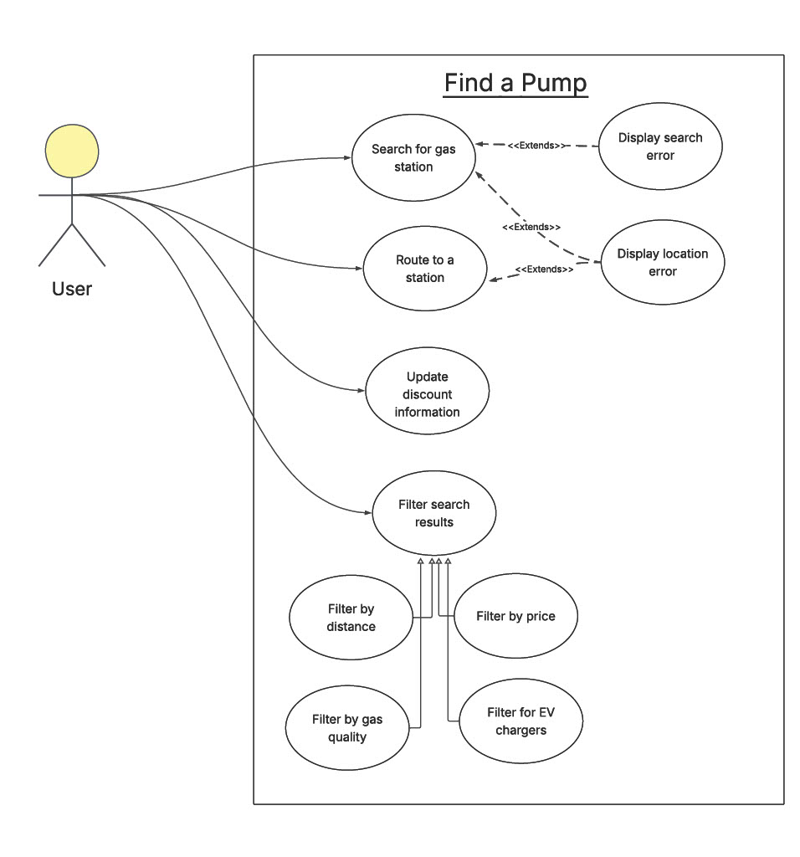
Table 3: https://github.com/kylercressall/cs4400-findapump/blob/main/documentation/UML/Find%20a%20Pump%20--%20Use%20Case%20Diagram.pdf
The use case diagram outlines 12 primary user interactions, including searching for stations, applying filters, entering discounts, viewing station details, and navigating via Google Maps. All use cases are maintained at the same abstraction level to ensure balanced granularity.
Class Diagram

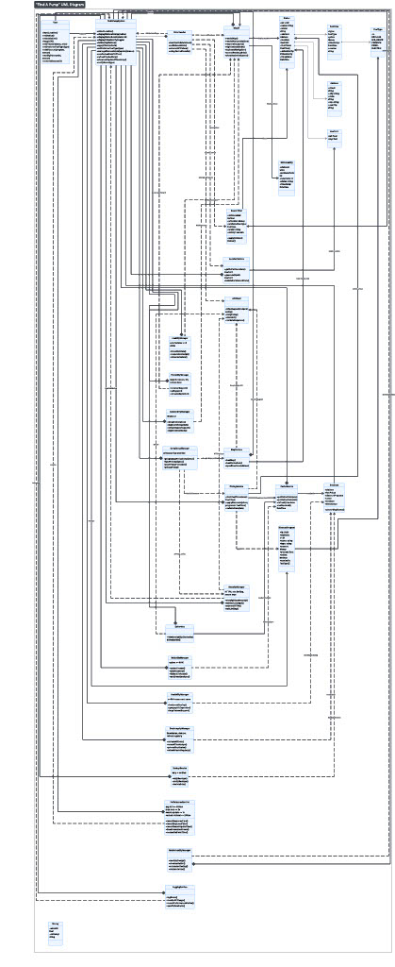
Table 4 https://github.com/kylercressall/cs4400-findapump/blob/main/documentation/UML/Rough%20Uml-Find%20A%20Pump.pdf
The class diagram enforces high cohesion and loose coupling. Each class contains no more than five instance variables and ten methods. Major classes include:
- Station
- FuelPrice
- DiscountManager
- MapService
- APIService
- CacheManager

Testing/QA
Test Plan
Introduction:
The purpose of this test plan is to ensure the Find a Pump meets its functional and non-functional requirements and behaves correctly under expected and edge-case conditions.
Scope:
Functional requirements include:
- Location detections
- Stations displayed on the map
- Station details
- Search filtering
- Preferred fuel type
- Discounts
- Caching/offline mode
- Timestamps
- Refresh behavior
- Error handling for:
  - No results
  - API failures
  - Cached fallback
- API data validated
- Timestamps present
- Routing opens correctly.
Non-functional requirements include:
- Performance
- Reliability
- Usability
- Scalability
- Security
- Maintainability
- Portability
- Accuracy
- Accessibility
- Logging/monitoring
- Backup/recovery
Test Approach:
- Unit tests
  - Validation
  - Discount math
  - Filtering/sorting logic
  - Catching behavior
- Integration tests
  - Frontend
  - Backend
  - Database cache
- c. System tests
  - Real user flow across map/list
  - Filters
  - Station details
  - Offline mode
- Non-functional tests
  - Performance timings
  - Accessibility checks
  - Basic security checks
  - Resiliency
Test Data:
A seeded station dataset with:
- Multiple stations, fuel types, prices, and varied distances
- Some missing or invalid API fields for validation tests
- Discount programs matching specific stations
- Cached snapshot with timestamps
Test Environment:
The testing environments will be finalized by the end of sprint 2. It will most likely include multiple browser types, device types, online and offline modes, and location services allowed and blocked.
Test Cases:
Test cases will be finalized by the end of sprint 2. They will cover the expected scope of the testing plan with pass/fail information included.
Pass/Fail Criteria:
Functional: 100% of functional test cases must pass.
Non-functional: Must meet defined thresholds
Any crash on common user flow is a fail.
Schedule:
This testing plan will be finalized by the end of sprint 2. The unit testing and integration testing will be performed in sprint 3. System testing and non-functional testing will be carried out in sprint number 4.
Quality Assurance Metrics
Design metric:
The design metric chosen for Find a Pump is high cohesion. This will be achieved by clearly dividing responsibilities and ensuring that each module has a single, well-defined purpose. High cohesion improves maintainability, makes the system easier to understand, and helps isolate defects, which in turn facilitates faster debugging and more reliable enhancements.
Testing metric:
The chosen testing metric for Find a Pump is testing pass rate. The project will track the percentage of automated and manual tests that are passed during each test cycle. The goal is to maintain a 100% pass rate before release to ensure that core functionality remains stable and that regressions are caught early.
QA metric:
Find a Pump is committed to maintaining a high defect removal efficiency (DRE) in order to catch as many defects as possible before release. This metric measures the proportion of defects found before deployment compared to those found after release. A high DRE reduces the number of escaped defects and helps ensure a higher quality product for end users.
Process metric:
To ensure that Find a Pump is released in a timely manner, sprint velocity will be monitored and evaluated. Tracking sprint velocity allows the team to measure how much work is completed per sprint, improve planning accuracy, and identify potential slowdowns, while still maintaining a strong focus on quality.
Maintenance metric:
For maintenance, find a Pump will monitor the size of its maintenance backlog and aim to keep it as small as possible. This will be achieved by consistently prioritizing and addressing bugs, technical debt, and post-release issues, helping ensure long-term stability and maintainability of the system.

